BEACH HUT CLASSIC BBQ AT SMITH’S POINT ON 6/26/15
SPONSORED BY MEDICAID AME BOARD
OPEN TO ALL AME UNITS.
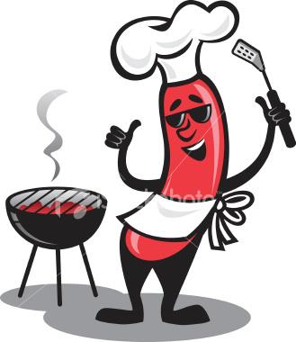
Main Dishes: Sides: Salads:
Hamburgers Sliced Cheese Macaroni
All Beef Frankfurters Tomato and Onion Potato Salad
BBQ Chicken Sliced Pickles Coleslaw
Sausage & Peppers Sauerkraut
Veggie Burgers Bread and Rolls
Chicken Fingers Lettuce Beverages:
French Fries Corn on the Cob Soda and water
Watermelon Cash Bar!
HRS: 5:30 TO 9:30 PM
PARKING IS FREE AFTER 5:00 PM 50/50 and gift card raffle
$30 pp. includes tax and gratuity Limit 250 people.
Band playing is: Legendary Murphy’s Must pay by 6/19/15

For Information:
Great River: Mary Lou Fava or Willie Smith
Smithtown: Ann Marie Galardi
Mary Gordon: Joan Vaccaro or Doreen Graci
Riverhead: Sandra Schloss-Washington, Aimee Creato and Shirley Melendez.

